Bearcat Job Search

Software Requirements Specification

Version: 1.0.2

June 11, 2020

Team Members
Anil Bomma
Yugandhar Rao Mamidi
Prasanna Kumar Potnuru
Santhosh Kumar Bollena
Sai Chandu Gampa
Mahendar Reddy Surkanti

Submitted in partial fulfilment
Of the requirements of
CSIS 44-691 Graduate Directed Project 1

Revision History

Date | Description | Author | Comments
June 10, 2020 | Added project introduction | Anil Bomma,  Sai Chandu Gampa | Added chapter – 1 introduction.
June 10, 2020 | Added project general description | Yugandhar Rao Mamidi,  Mahendar Reddy Surkanti | Added chapter – 2 General Description.
June 10, 2020 | Added project requirements | Santhosh Kumar Bollena,  Prasanna Kumar Potnuru | Added chapter – 3 Specific and functional requirements.
June 10, 2020 | Added ER diagram | Santhosh Kumar Bollena,  Mahendar Reddy Surkanti | Designed ER diagram.
June 11, 2020 | Added description for ERD and Created Mockups | Yugandhar Rao Mamidi, Prasanna Kumar Potnuru, Sai Chandu Gampa | Added prototypes under GUI

Document Approval

The following Software Requirements Specification has been accepted and approved by the following:

Signature | Printed Name | Title | Date
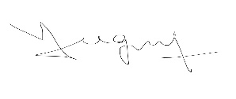 | Yugandhar Rao Mamidi | Mr. | June 10, 2020
 | Prasanna Kumar Potnuru | Mr. | June 10, 2020
 | Sai Chandu Gampa | Mr. | June 10, 2020
 | Anil Bomma | Mr. | June 10, 2020
 | Santhosh Kumar Bollena | Mr. | June 10, 2020
 | Mahendar Reddy Surkanti | Mr. | June 10, 2020
Table of Contents

Table of Contents Page Number

- Introduction
  - Purpose
  - Scope
  - Definitions, Acronyms, and Abbreviations
  - References
  - Overview
- General Description
  - Product Perspective
  - Product Functions
  - User Characteristics
  - General Constraints
  - Assumptions and Dependencies
- Specific Requirements
  - External Interface Requirements
    - User Interfaces
    - Hardware Interfaces
    - Software Interfaces
    - Communications Interface
  - Functional Requirements
  - Use Cases
  - Class/Objects
  - Non-Functional Requirements
3.5.1. Performance
3.5.2. Reliability
    - Availability
    - Security
    - Portability
  - Inverse Requirements
  - Design Constraints
  - Logical Database Requirements
  - Other Requirements
  - Prototypes (for complete project)
  - Use Case Diagrams
- Design
4.1. ER diagram
4.2. GUI
- Analysis Models
4.1. Data Flow Diagram
4.2. Sequence Diagram

CHAPTER – 1

INTRODUCTION

  - Purpose

At Northwest Missouri State University we have a career-center office were students update their resume in a professional way for better opportunities in the job market. But as of now at Northwest, we don't have any job portal or job searching application, and every time when the recruiters want to hire students they have to reach the particular department head at the university. In order to communicate with the students and to inform them about the job opportunity, the department head has to send the mail to everyone.

These things make difficult to hire any students to solve all the above problems we have decided to build a web-application “Bearcat Job Search” were student can upload their profile and search the relevant jobs based on their degree.

  - Scope

Initially, the student has to register in the Bearcat Job Search application, after the registration, they have login in order to access the application and has to update their profile such as name, experience, knowledge on software programming languages or software tools, the average salary expectation like so. Student can also upload their resume and integrate their GitHub or Linked-in account into their profile.

Recruiters can be accessed the Bearcat Job Search application once they are added by Admin. Once they have added to the system, they can check for student's profile and they can filter based on their requirements specifications such as Front-end developer, Back-end developer, Full-stack developer, DBA, Dev-Ops, Chemist, Agriculture, HR, Business Management, etc.

  - Definitions, Acronyms, and Abbreviations

The following terms, acronyms, and abbreviations are used throughout this document.

Admin: Admin is the super user, how has complete access to the application.
Recruiters: These are the hiring team and they can view all student's profiles and can download students' resumes.
Student: Student refers to job seekers, they can search for the relevant jobs and can apply to them if they are interested and can also make those jobs as a favorite for the future use or reference.
GitHub: GitHub brings together the world's largest community of developers to discover, share, and build better software.
Linked-in: Manage your professional identity. Build and engage with your professional network. Access knowledge, insights, and opportunities

  - References Scope

- https://www.linkedin.com/
- https://www.indeed.com/
- https://www.monster.com/
- https://www.careerbuilder.com/
- https://www.glassdoor.com/index.htm

  - Overview

Bearcat Job Search application can provide lots of opportunities to find numerous jobs on their degree, work experience, and help the students to get their dream job. As well as the Recruiters are also benefited by filtering out there students based on the profile and work experience, and this application makes it so much easy to communicate with the candidate by providing live chat.

CHAPTER – 2

GENERAL DESCRIPTION

- Product Perspective

The main perspective of the Bearcat Job Search application is to be helpful to the recruiters and students in finding their employee and employers respectively.

- Product Functions

As a part of organizing, we have divided the tasks among the team members and planned to conduct recursive team meetings daily to know the daily progress of the assigned tasks.

- User Characteristics

The user of the application will be provided to access the application in different ways, one is through student and another is a recruiter. Students first need to register under the registration page in order to view the job posting and upload their respective resumes or CVs. If a recruiter wants to access the application first they should get permission from the admin through email, So that each recruiter will be provided with a unique email id and password to view and access the profile of the students.

Students are also provided to edit and update their profiles on daily basis. They can also search the jobs based on technologies and designations.

- General Constraints

In order to develop the application, we have formed into a team of 6 members and divided the tasks and planning to complete the project in six months. As a part of the submission, the deadline for phase-1 is mid of June 2020.

In order to complete the project on time. We fixed deadlines through frequent zoom meetings.

- Assumptions and Dependencies

As a project plan. Firstly we are gathering all the requirements necessary for the project development and then planned to design ER-Diagram to represent the entity relations between the models. Further, the tasks are divided as follows:

- Initial project set up for frontend and backend in GitHub.
- Team will write the migration script where all the database schema from the ER diagram will be created automatically from the migration script.
- Creating Models for the Project.
- Implementing authentication logic in the backend for login functionality.
- Creating API for registration and login form in back-end.
- Designing UI Registration Page for Students.
- Designing UI Login Page for Admin, Recruiter, and Student.
- Testing and Debugging the Application with login and registration functionality.

CHAPTER – 3

SPECIFIC REQUIREMENTS

  - External Interface Requirements

    - User Interfaces
      - Registration Page: Students will register to the application from a registration form.
      - Login Page: Students, Recruiter, Admin can login to the application with this User Interface.
      - Forgot Password Page: Students can retrieve their password here.
      - Student Welcome Home Page: All the job postings from recruiter and admin will be listed over here. Students will have a search bar to search from the jobs posted.
      - Recruiter Home Page: All the students will be displayed in tabular format. Recruiters can search the student based on the interested position of the student or based on name.
      - Student Profile Page: Student profile page where a student can edit their profile details.
      - Recruiter Profile Page: Recruiter profile page where recruiter can edit their profile details.
      - Display Resume Page: Where Recruiter and Admin can view the resume of the student and can download it.
      - Admin Add Recruiter: Admin can add new Recruiter here.
      - Add New Job Post: Admin and Recruiter can add new job post here.
      - Contact Us Page: Details of the Admin will be displayed so that if a Recruiter or Student has any queries can contact the Admin.
      - FAQ Page: Some frequently asked questions from the students and recruiters can be displayed over here.
    - Hardware Interfaces
• Processor: Minimum 1 GHz; Recommended 2GHz or more
• Ethernet connection (LAN) OR a wireless adapter (Wi-Fi)
• Hard Drive: Minimum 32 GB; Recommended 64 GB or more
• Memory (RAM): Minimum 1 GB; Recommended 4 GB or above
    - Software Interfaces
• Visual Studio Code
• Node JS
• React JS
• MySQL Workbench
• Adonis JS
    - Communications Interface
• Chrome
• Safari
• Firefox
  - Functional Requirements
    - Roles in the Application
      - Admin
      - Recruiter
      - Student
    - Responsibilities of each role

      - Admin
        - Admin can post job requests.
        - Admin can edit and delete the posted job request.
        - Admin can add Recruiter.
        - Admin can search for the student based on their profile (Searching for Students interested in Full Stack Development).
        - Admin can view all student profiles.
        - Admin can view the Student Resume and if the admin wants to download it he/she can.
        - Admin can edit Recruiter and Student profile details.
        - Admin can view the students GitHub account.
        - Admin can view the students LinkedIn account.
        - Admin can send a mail to the student.
        - Admin can live chat with students

      - Recruiter
        - Recruiter can post job requests.
        - Recruiter can edit and delete the posted job request.
        - Recruiter can search for the student based on their profile (Searching for Students interested in Full Stack Development).
        - Recruiter can view all student profiles.
        - Recruiter can view the Student Resume and if the recruiter wants to download it he/she can.
        - Recruiter can view the students GitHub account.
        - Recruiter can view the students LinkedIn account.
        - Recruiter can send a mail to the student.
        - Recruiter can live chat with students.

      - Student
        - Register into application to access the functionalities.
        - Login to application using the login credentials from the registration form.
        - Password retrieval can be done if the Student forgets their password.
        - Students can update their details like (Name, alternate email, description, Experience, Salary expectation, etc...).
        - Students can upload their resume in .pdf, .docx, .doc format.
        - Students can search for jobs posted.
        - Students can apply for the job he/she might interested in.
        - Students can integrate GitHub profile into application.
        - Students can integrate LinkedIn profile into application.

CHAPTER – 4

DESIGN

4.1 ER Diagram
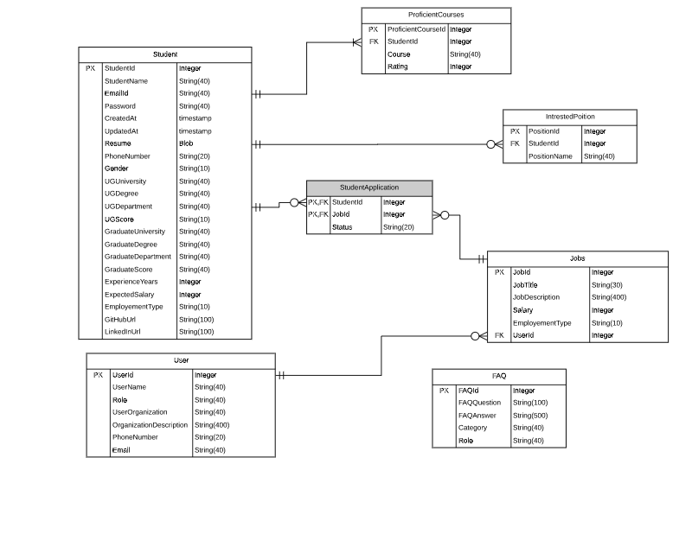
Fig: 1 ER diagram for “Bearcat Job Search”

From the Fig: 1, we have our ER-Diagram of “Bearcat Job Search” which includes entities: Student, User, ProficientCourses, InterestedPosition, Jobs, FAQ. In the Student entity we have many attributes like StudentID of type integer, StudentName of type String, etc. User entity have attributes like UserId of type integer etc. Similarly based on the type of the entity and model, consisting of all purposeful attributes as shown in the above diagram.

The relationship between the entities in the diagram differs from one another depending upon the constraints they have. Considering Student and ProficientCourses entities, the relationship is one to many because one student must have at least one or more ProficientCourses. And also one student can show interest in zero or more positions. Coming to Student and Jobs entities, we have an associative entity StudentApplication connecting both the entities in a relationship is Many to Many. In the associative entity, we have included both the keys (PK, FK) StudentId, JobId and also Status attribute of type string which tells the current status of the application. In the User entity, we have a special attribute named Role which can be Admin or Recruiter. Admin can delete or add jobs and Recruiter can also delete or add jobs upon successful access given by the Admin.

4.2 GUI

Registration Page:
This is a registration page where students can register by providing the details as mentioned in the image like firstname, lastname, email, password etc

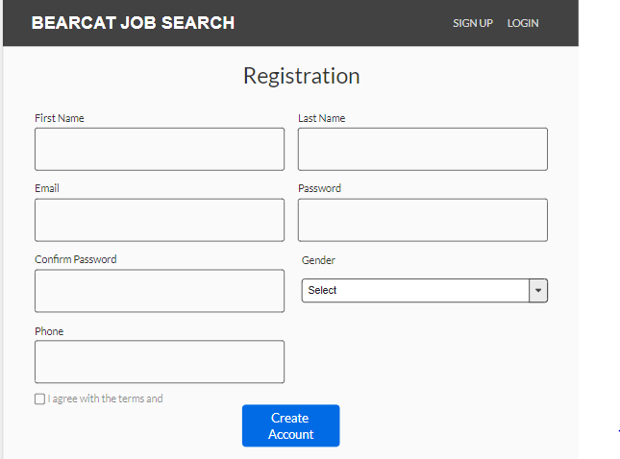

Login Page:
This is a login page, where students should enter their email and password details given in the registration page in order to view the job postings.
If the user has forgotten their password they can reset the password by clicking on “Forgot Password” link

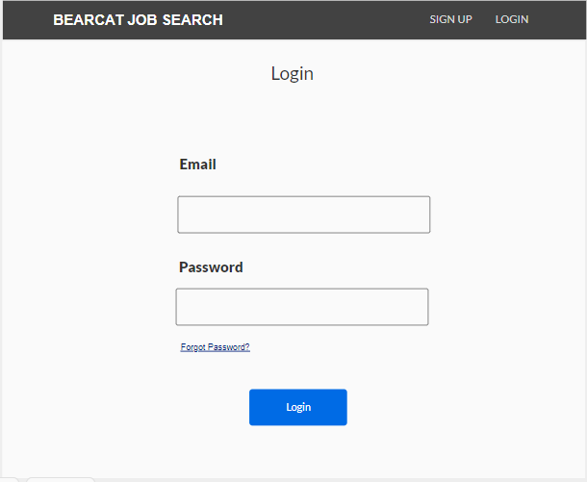

Job Postings:
This is a job posting page, where the student can view and apply the respective jobs based on job position and they can also view the total jobs applied

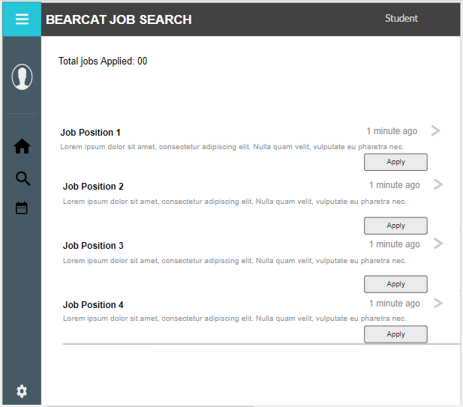
Job Description:
When the student clicks on the job position in the job posting page, they will be redirected to this page, where job position information, organization and description of the job can be viewed. If the student is interested in the job position then they can apply by clicking on “apply” button or else he can be navigated to previous page by clicking on “cancel” button

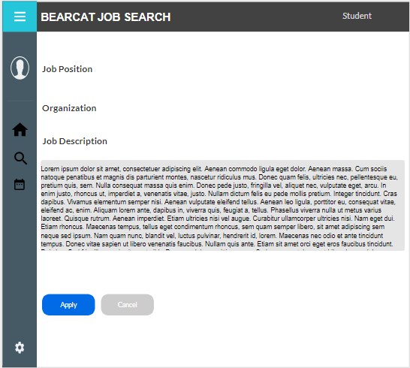

Customer Request Form:
This is a customer request form, where the user can enter their details and mention the issue with respect to accessing the page and their inputs regarding the application

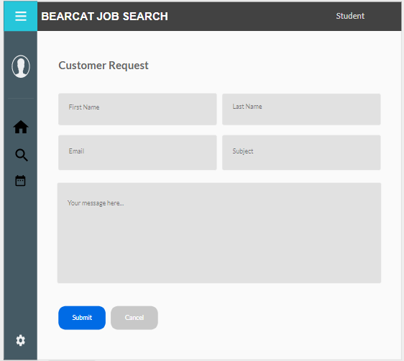

Student Edit Profile:
This is a student profile page, where the student can edit the profile and upload their updated resume and their expected salary as mentioned in the image

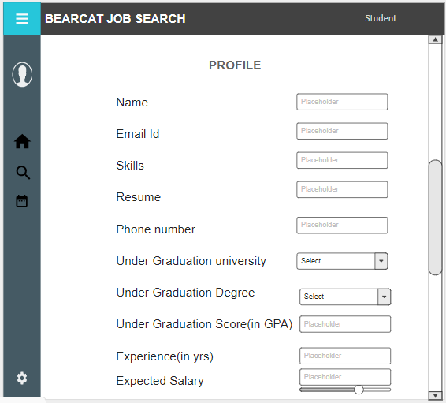

Student Profile Access to Recruiter:
This a student profile view of the recruiters where they can view the student detailed profile and view the resume through the text view option in order to know whether the student profile suits the recruiter vacant position or not

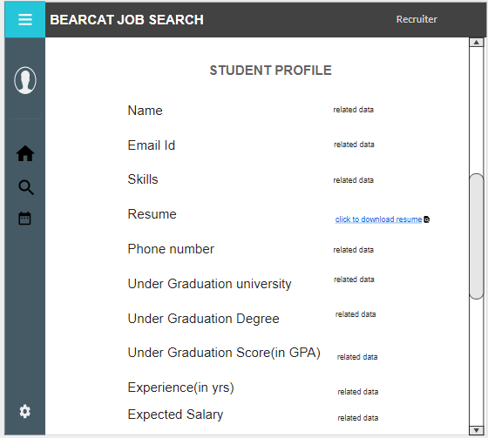

Recruiter Access Rights Form:
This is a recruiter access rights form where the admin has the right to give the permission to the recruiter to access the student profiles

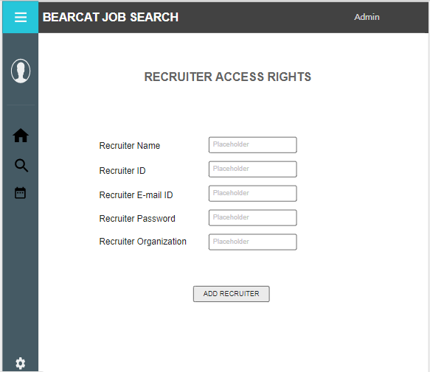

Students Listing Form:
The admin has the access to edit or delete the students by performing background checks on the student profiles whether student profile is genuine or not

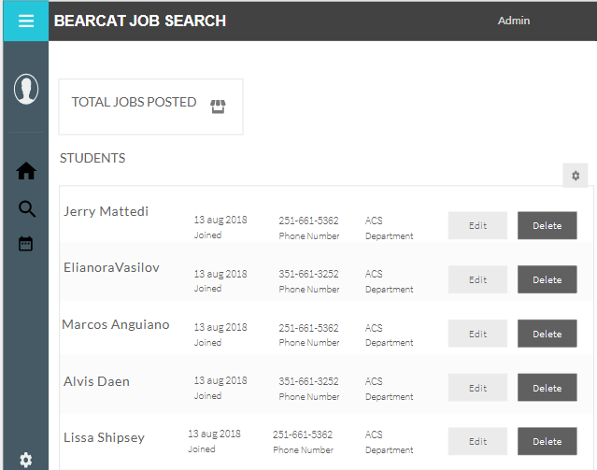

Student Profile Information for Recruiter:
This is a page for recruiter to view the student profiles, they can view the student profiles by clicking on the “click to view” button

